URL | Screenshot for 360schooltrips
http://blog.goway.com/globetrotting/2016/07/amazing-scenery-beaches-krabi-thailand/ | 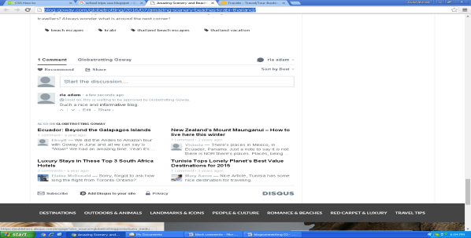
https://blog.paniniamerica.net/2016/10/30/panini-america-offers-halloween-edition-of-where-is-it-weekend-with-treats/ | 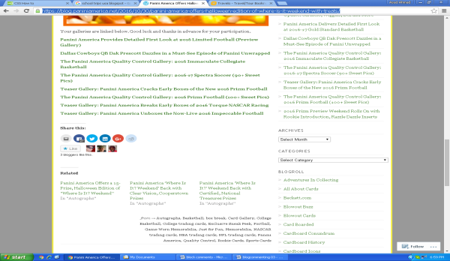
http://writeblogread.blogspot.com/2012/11/school-trip-to-sitges-jordi-b-1r-batx-a.html | 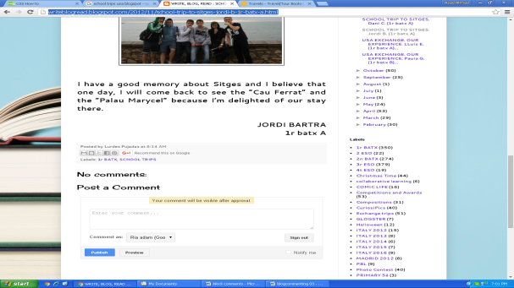
http://blog.vitalchek.com/birth-certificates/school-enrollment/summer-travel-planning-for-college-students/#comment-13396 | 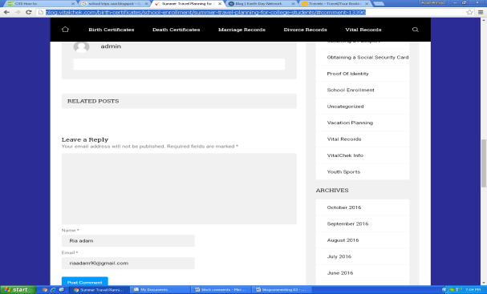
https://www.fcc.gov/news-events/blog/2014/06/06/closing-wi-fi-gap-americas-schools-and-libraries | 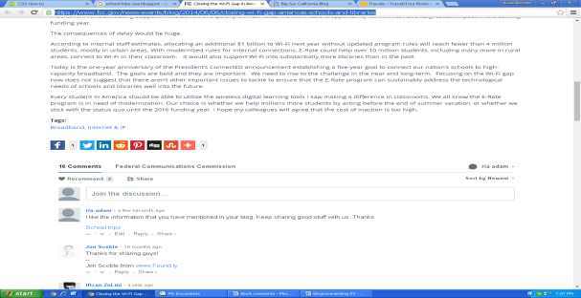
http://www.thebigsurblog.com/ | 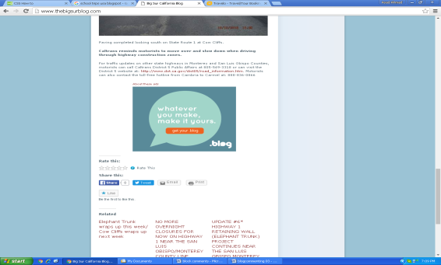
http://www.caremin.com/blog/2016/11/never-too-late-for-first-steps/#comment-9130 | 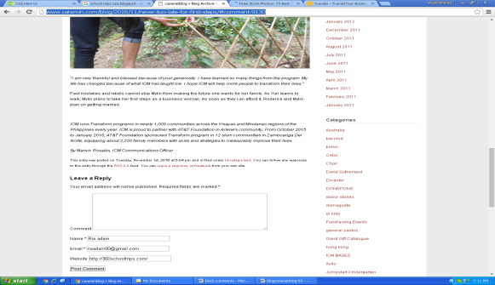
https://designschool.canva.com/blog/free-stock-photos/ | 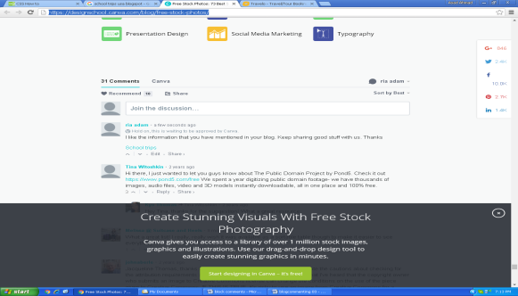
http://blog.freepeople.com/2016/11/kids-alright-meet-larsen/#comment-4002644 | 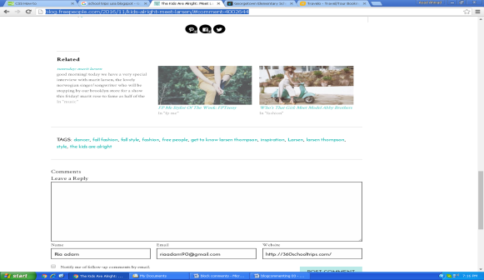
https://georgetown.edublogs.org/2016/10/30/week-8-october-into-november/comment-page-1/#comment-1542 | 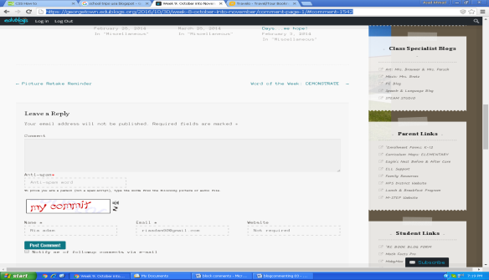
http://blog.homeaway.com/home/how-to-give-your-home-the-charm-of-a-rustic-cabin#comments-57f7a140c534a5052aa50adf= | 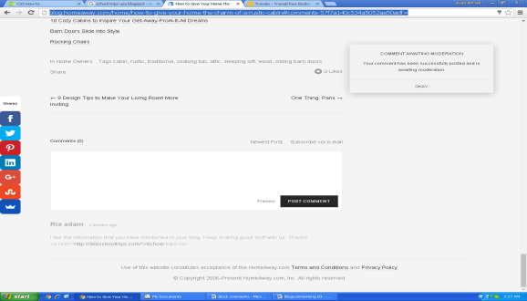
https://education.blogs.archives.gov/2016/06/24/due-process-japanese-relocation/ | 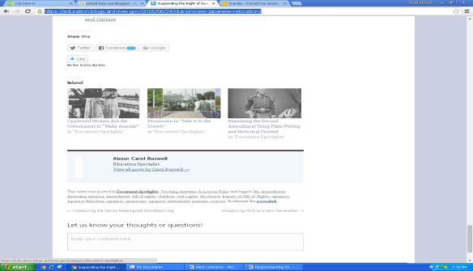
http://tobifairley.com/blog/2016/tobi-tv-5-ideas-for-using-black-and-white-in-your-home/comment-page-1/#comment-223194 | 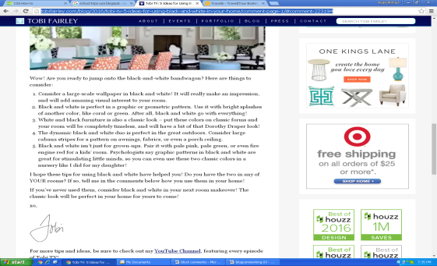
http://www.statravel.com/blog/2014/06/15/5-tips-to-working-abroad-in-australia/#comment-21452 | 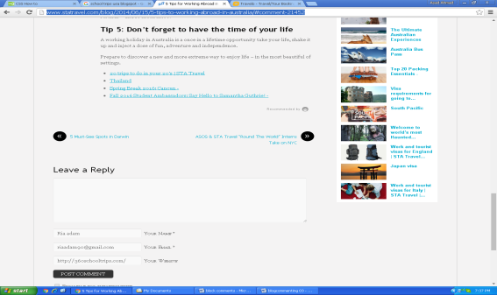
http://www.disneytouristblog.com/101-best-disneyland-tips/comment-page-9/#comment-1669846 | 